Sri Lanka Institute of Information Technology



# Software Engineering Process & Quality Management

**SE3010**

**Lab 3 - In class self guided course**

IT22251114 JINAD INDUWITHWA A.G

# Quiz 01

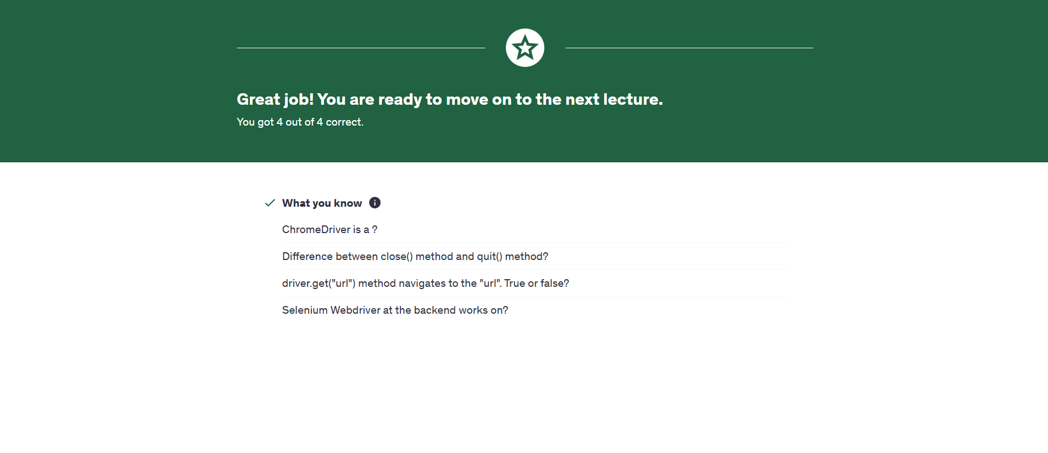

# Assignment 01

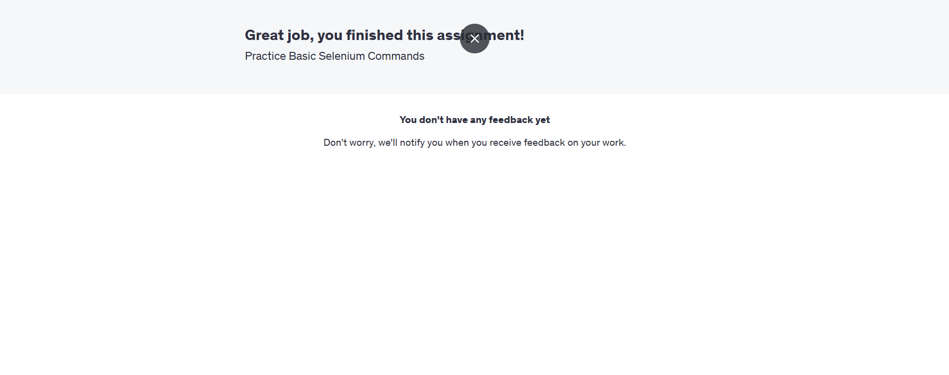

# Quiz 02

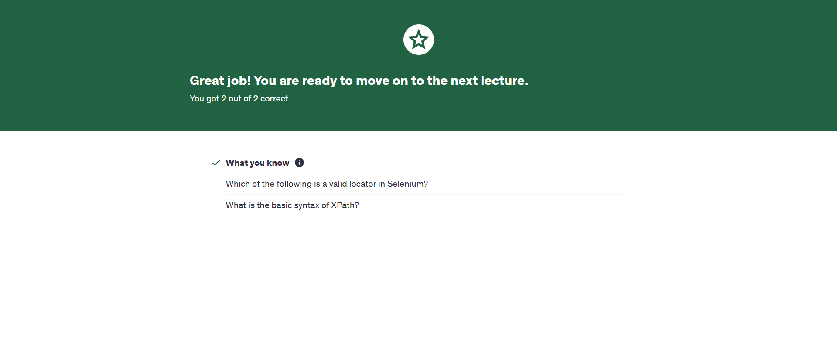

# Assignment 02